13.38: The equation 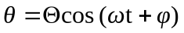describes angular SHM. In this problem, 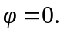
- 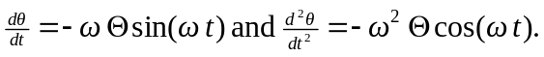
- When the angular displacement is 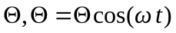, and this occurs at 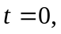so
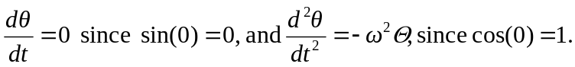
When the angular displacement is 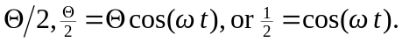
This corresponds to a displacement of 

